

**The University of Asia Pacific**

**Department of Computer Science & Engineering**

**Course Title: Database Management System Lab**

**Course ID: CSE 212**

**Submitted By:**

**Rezwan Kader**

**17201080**

**Sec-B1**

**Reshad Hasan Anonnyo**

**17201069**

**Sec-B1**

**Submitted to:**

**Nadeem Ahmed**

**Assistant Professor**

**The University of Asia Pacific**

**World**

**Giant**

**COMPANY**

**Database-2019’**

**Company Database**

**This is a database which contains basic information about famous**

**companies around the world. Customers can see & check out in which company should they invest and buy the stocks from. Also, details some of most famous founders are given.**

**The information which are going to be available in the database are given below:**

**Table: Companies**

**Attributes: company_name,category,founder,co_founder,founded, country,city,networth,stock**

**Relations: 1. Companies – locating – CountryLog**

1. **Companies – creators – FoundedBy**
2. **Companies – type - CatagoryType**
3. **Companies – offering – Services**

**Table: CountryLog**

**Attributes: country_name, city**

**Relations: 1. CountryLog – locating – Companies 2. CountryLog – Country – FoundedBy**

**Table: CatagoryType**

**Attributes: category**

**Relations: 1.CatagoryType- type – Companies**

**Table: FoundedBy**

**Attributes: founder, country, city, networth**

**Relations: 1. FoundedBy – country – CountryLog 2. FoundedBy – creator – Companies**

**Table: Services**

**Attributes: services_type, company_name, service_type_2**

**Relations: 1. Services – offering – Companies**

**ER Diagram Company Database Management**

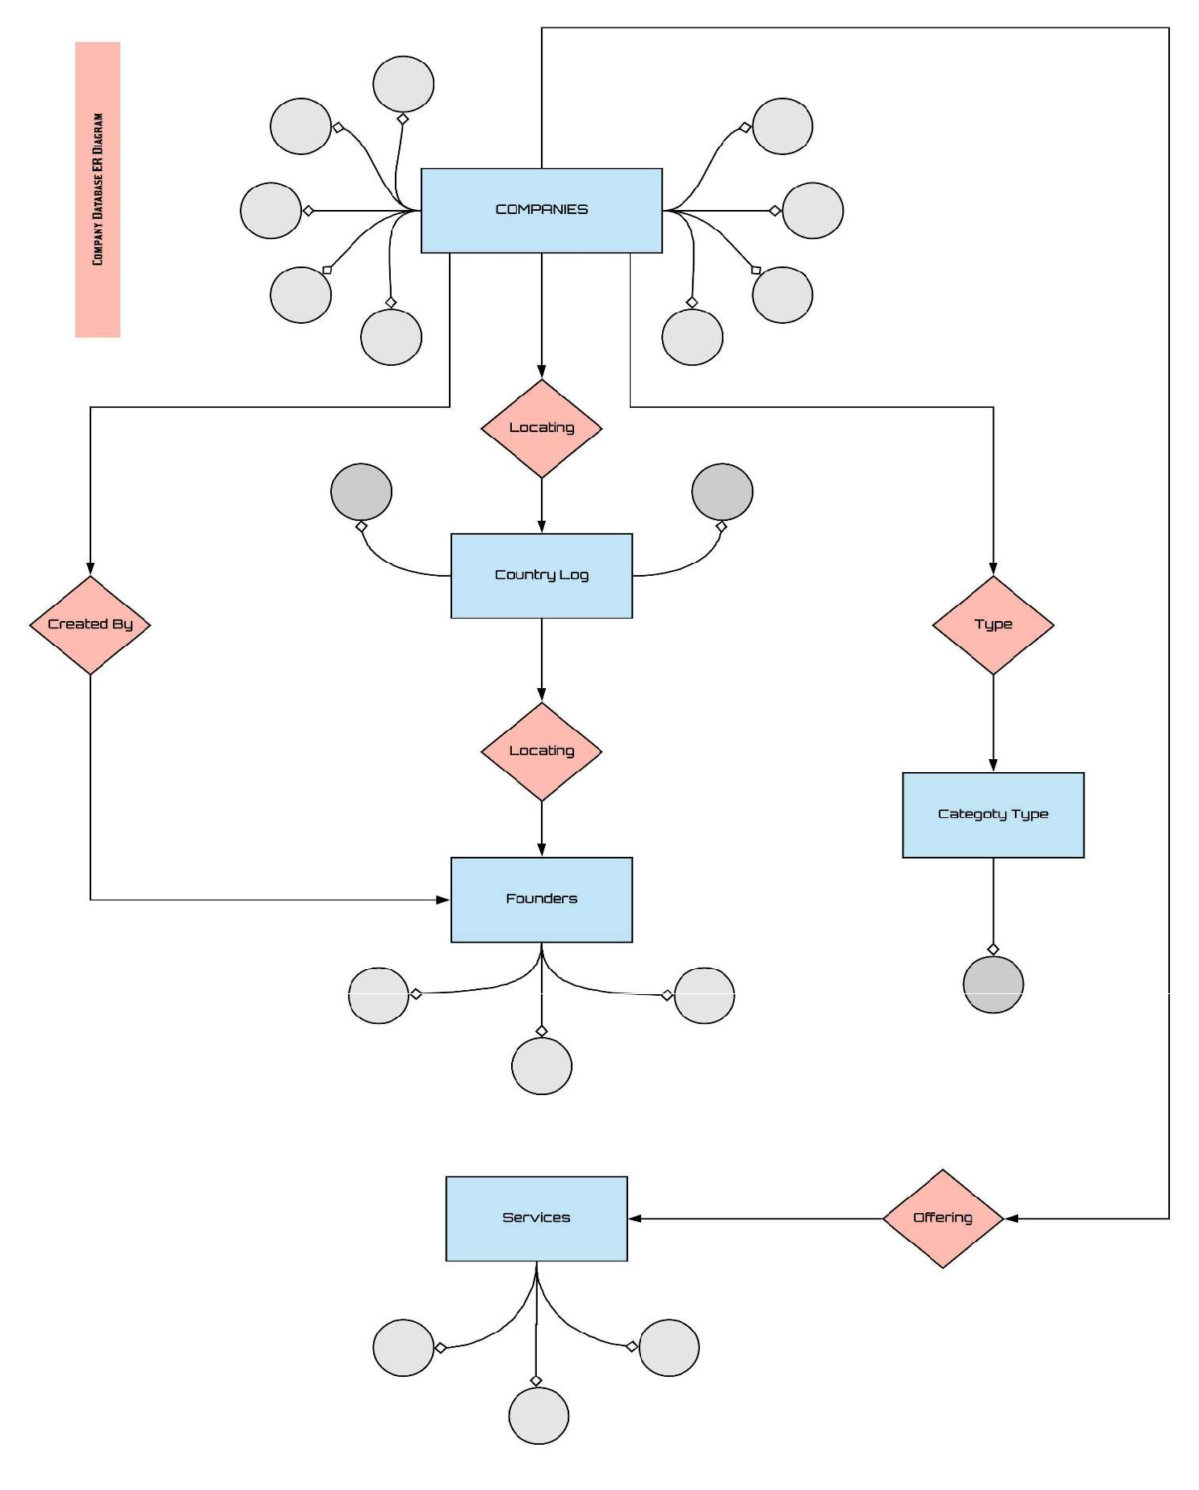

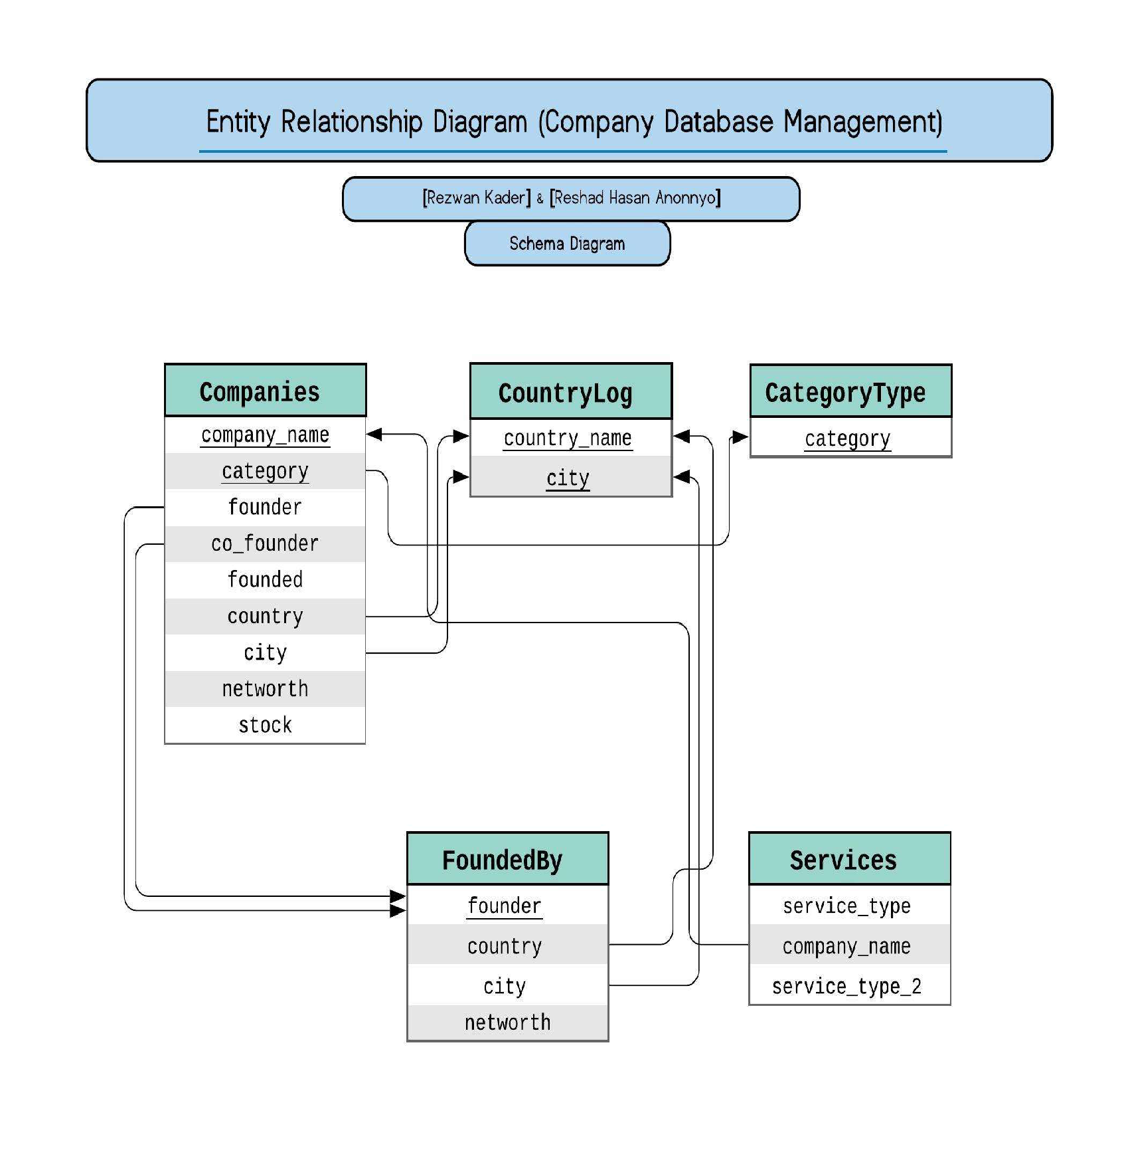

**Data Entries:**

**Data Entry of Company List:**

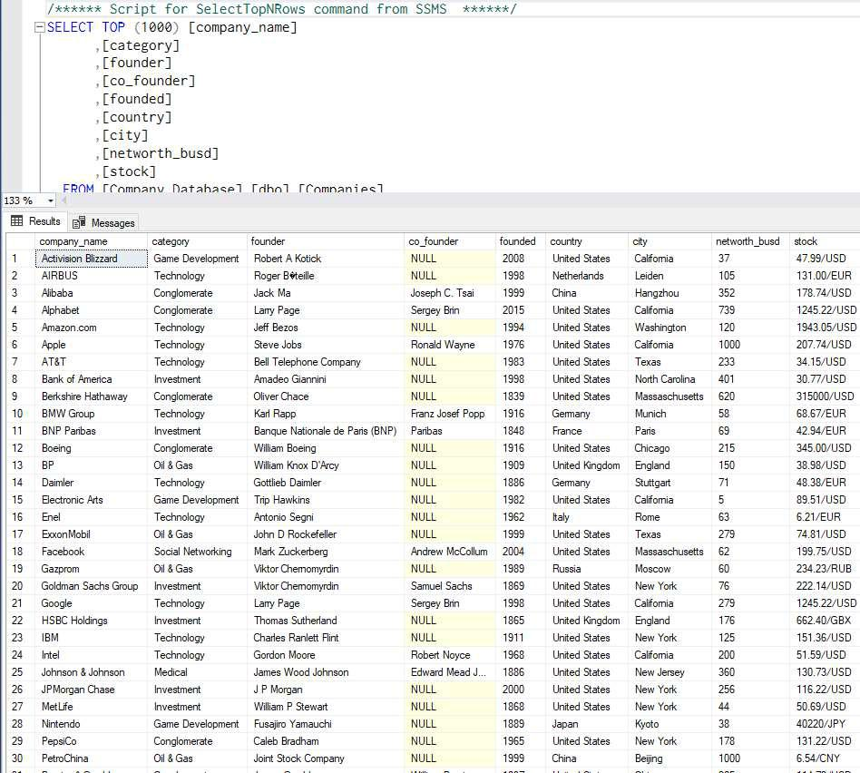

**Data Entry of Country Logs:**

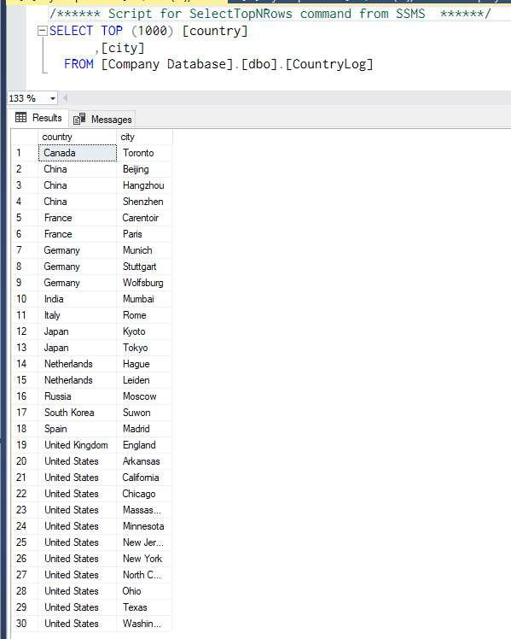

**Data Entry of Category Types:**

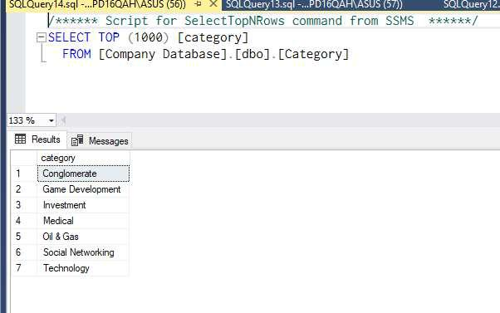

**Data Entry of Founder’s List:**

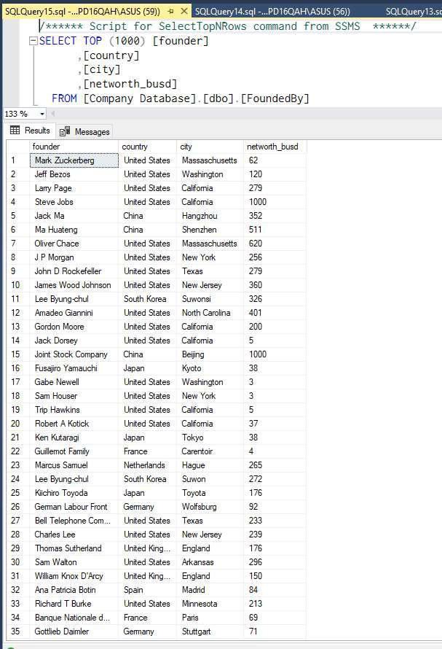

**Data Entry of Services:**

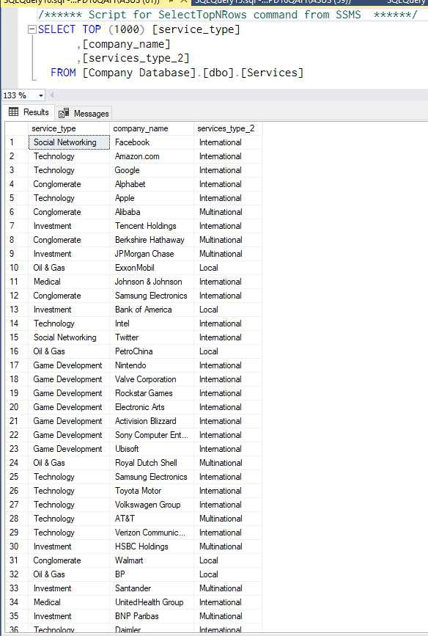

**Query-1**

**Using “Where” Clause**

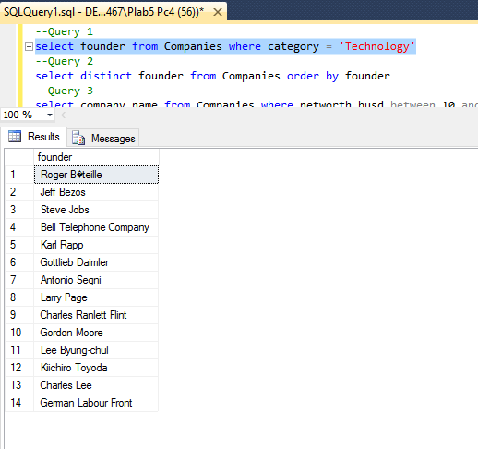

**Query-2**

**Using “Order By” Clause**

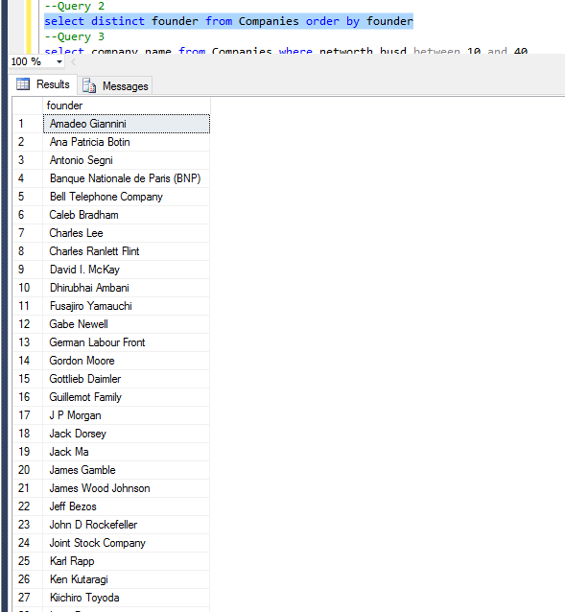

**Query-3**

**Using “Where with In-Between” Clause**

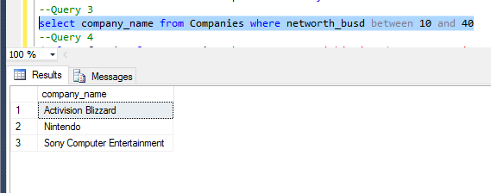

**Query-4**

**Using Set Operations**

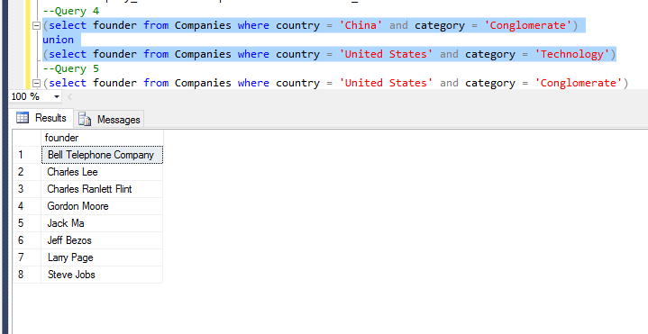

**Query-5**

**Using Set Operation**

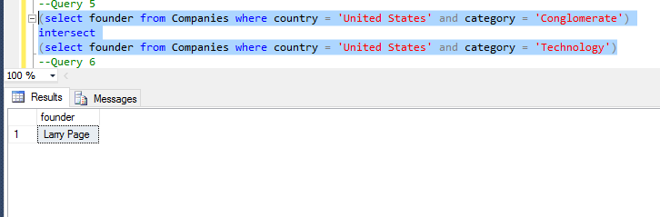

**Query-6**

**Using Set Operation**

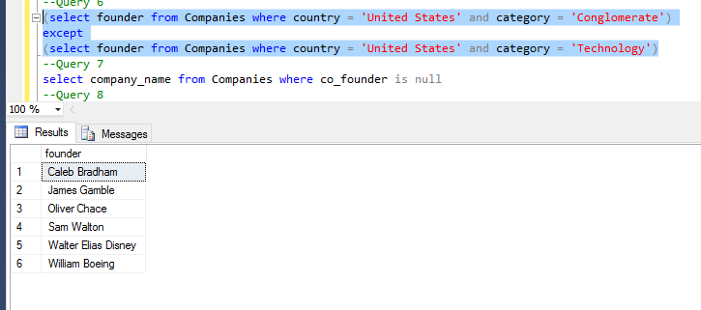

**Query-7**

**Finding a Table where there is NULL value**

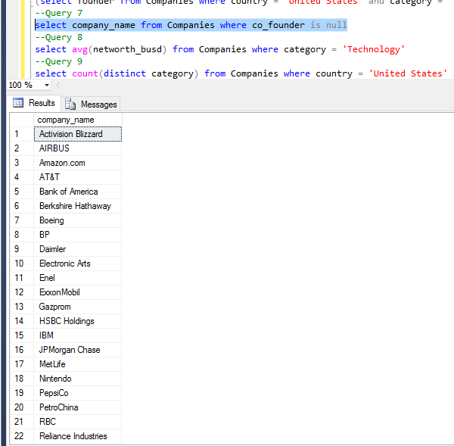

**Query-8**

**Finding average value**

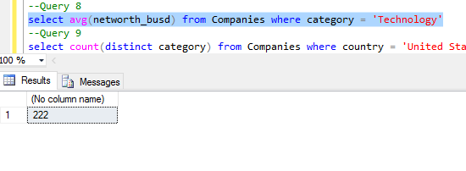

**Query-9**

**Counting items in specific range**

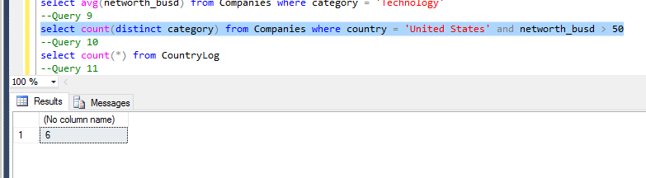

**Query-10**

**Counting all value**

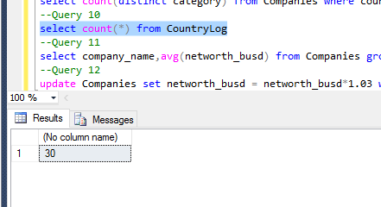

**Query-11**

**Group Query**

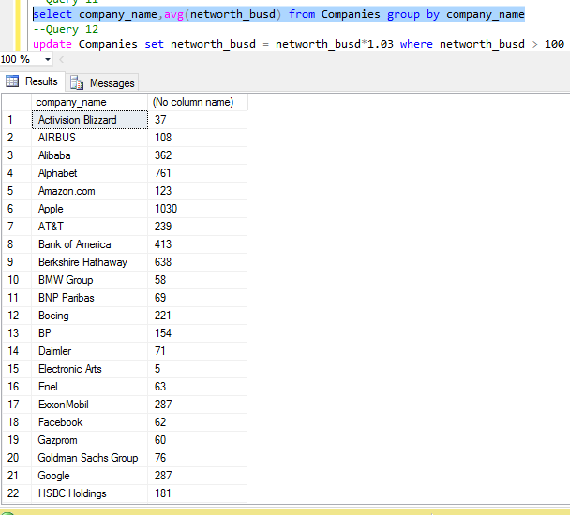

**Query-12**

**Updating table**

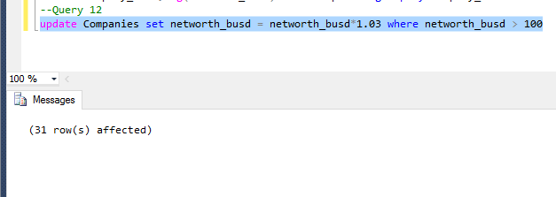

**Queries:**

**All queries performed**

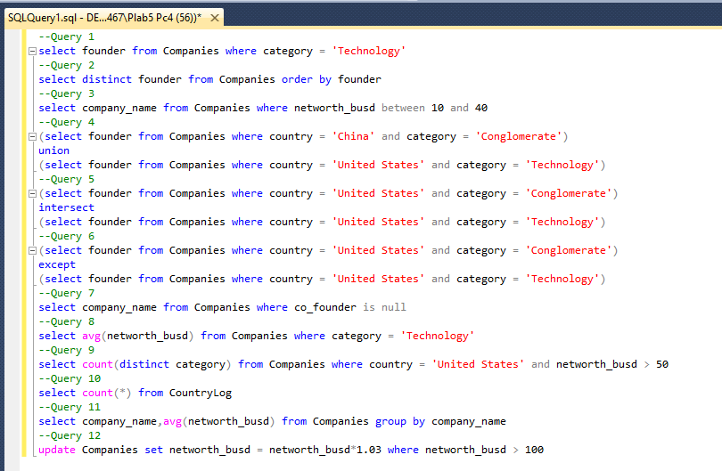

**Direct Link to Database Script File:**

**https://drive.google.com/open?id=1DycG8J9Hq5u6J0K4bbJYj2qtbVtG0ig-**

**Thank You….**

**Project Submitted By:** **Team [Trojan Paradox]**

